Automatic Quartzy Order Chrome Plugin

- Download (git clone https://github.com/cpflueger2016/Quartzy_Product_parser.git ) and unzip (from Slack) Quartzy Product parser

- Open Chrome, select Extensions and enable Developer Mode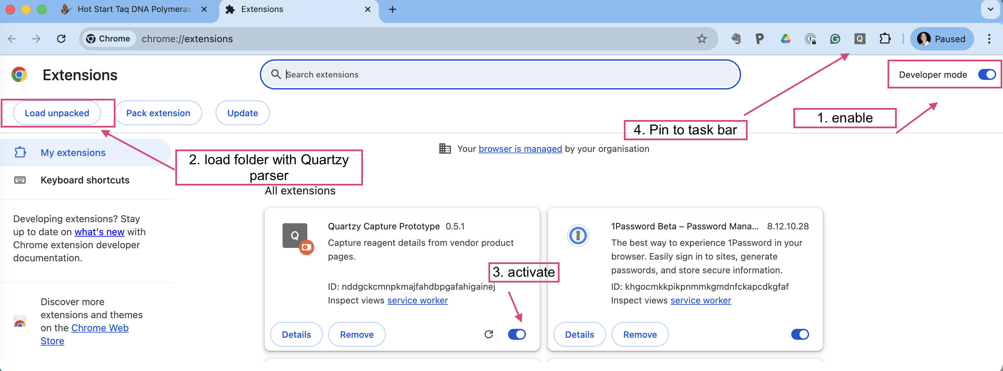

- Get tokens from Quartzy for:

  - Institute
  - Lab
  - Personal access token
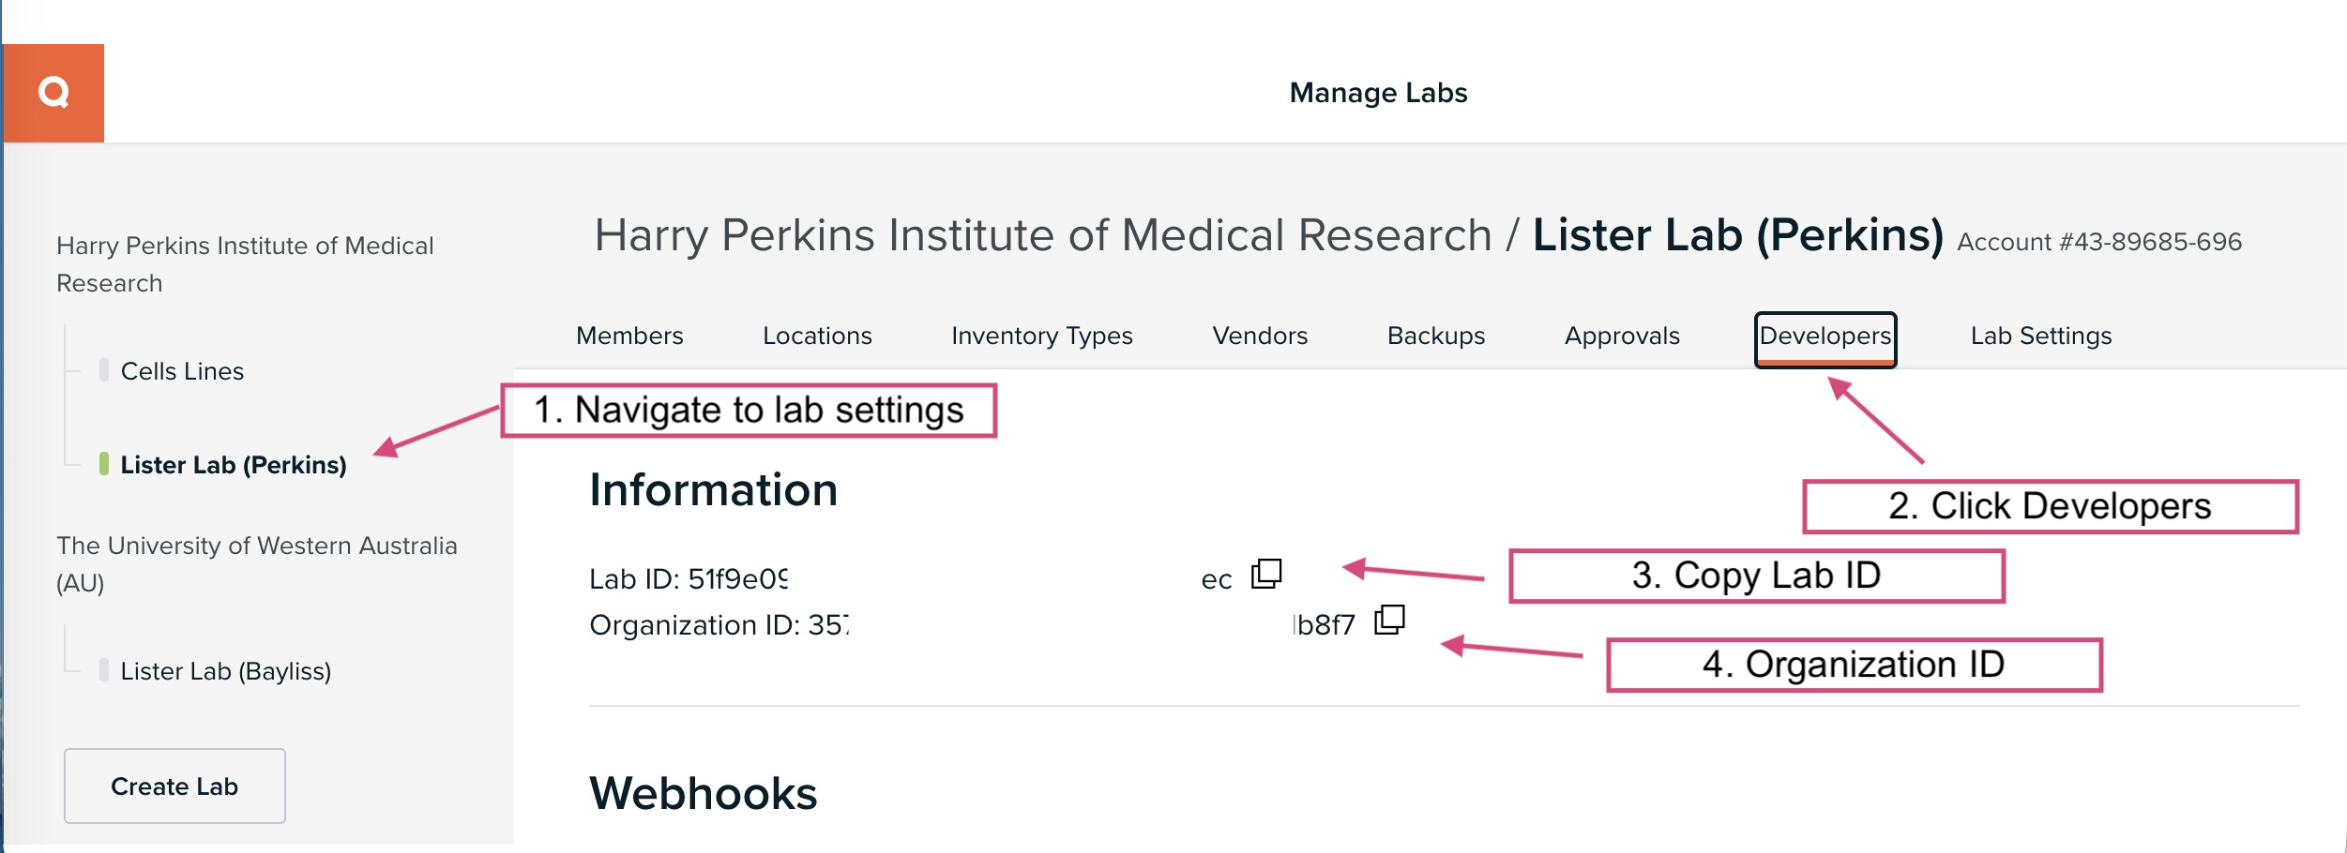
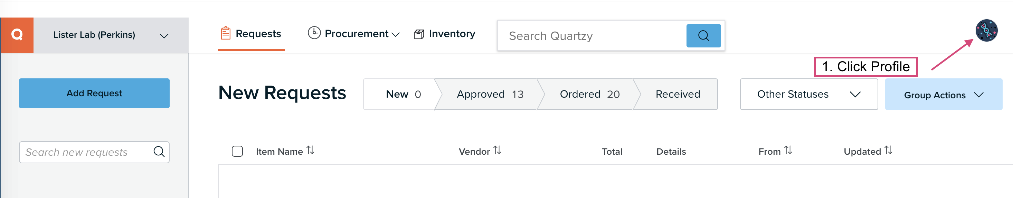

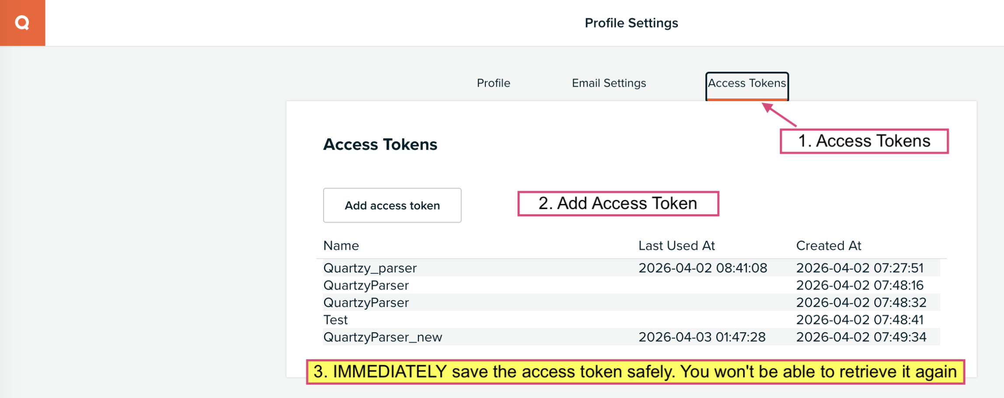
- Fill in the Tokens
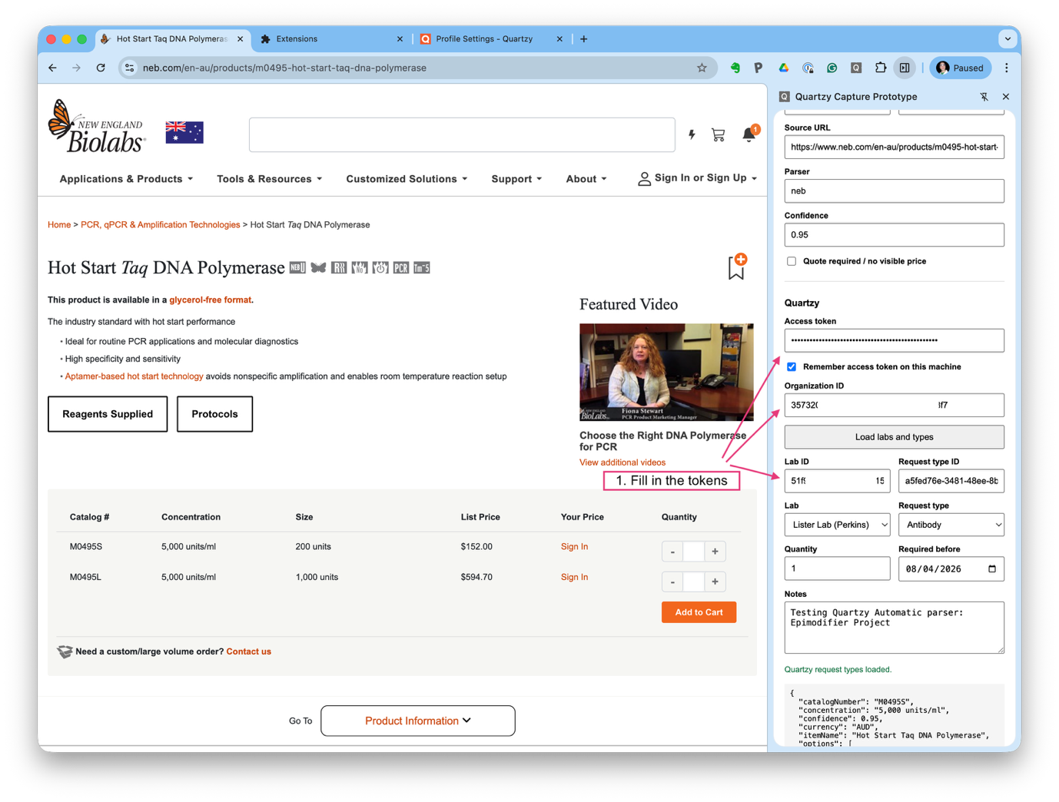
- Go to NEB or Thermo or Sigma:
  - search for product
  - click quartz parser in Chrome extension
  - fill in details (notes, type)
  - submit to Quartzy
- 
 